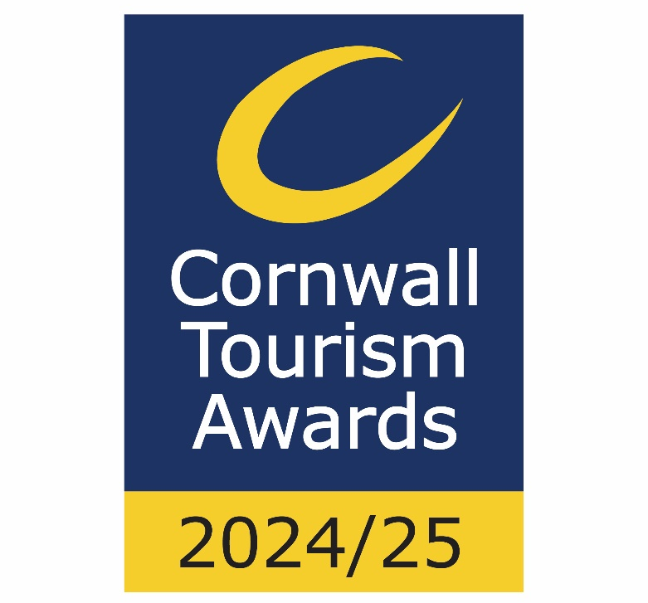

Wildlife Friendly Business of the Year

Recognises tourism businesses that demonstrate proven commitment to best practice in protecting and enhancing Cornwall’s wildlife and growing the environment.

This sample application form is for information only and all applications must be made via the online application system.

Eligibility criteria

- Directly involved in tourism, making a contribution to the visitor economy with a significant proportion of business generated by people visiting from outside the local area

Meets the tourism definition:
- 'Tourism product' covers a number of different categories including:
- Accommodation e.g. hotels, bed & breakfasts, guest houses, self-catering/serviced apartments, hostels, holiday boats, camping, caravanning, glamping, lodges, shepherds huts, chalets
- Hospitality i.e. a single food and beverage service business e.g. pub, restaurant, café, tea room, coffee shop, bistros, food and drink markets, kiosks & street food (in a regular location). [For these purposes the definition of a food and drink market is a collection of independent food and drink establishments with ancillary services (e.g. parking area, toilets, security, visitor information) and maintained by a management firm as an entity.]
- Guided tours & visitor experience that requires participation in an activity
- Cultural services, e.g. theatres, musical entertainment venues, sporting venues
- Visitor attractions that meet the visitor attraction definition: a permanently established excursion destination, a primary purpose of which is to allow access for entertainment, interest, or education and can include places of worship; rather than being primarily a retail outlet or a venue for sporting, theatrical, or film performances. It must be open to the public, with or without prior booking, for published periods each year, and should be capable of attracting day visitors or tourists as well as local residents.
- Businesses must actively work to promote and attract wildlife
- The business must be open during the judging period
- All sectors of the tourism industry are eligible to enter, including marine based and / or attraction/excursion orientated businesses that may not directly own or manage land or assets for wildlife.
- Businesses of all sizes can apply as this category is judged within the context and style of the business.
- Only tourism businesses who directly serve the end-users are eligible (i.e. the tourist/ visitor/ guest). Business to business agencies or intermediaries e.g. that manage business to consumer (B2C) presence for tourism businesses; would not be eligible.
- Businesses that serve food must have a minimum food hygiene rating of three out of five. The competition organisers reserve the right to refuse an application if this minimum requirement is not met at any point prior to the awards ceremony. An exception is made for new businesses who have not yet been graded
- Businesses that have been trading for at least three months and up to two years when applications open are strongly recommended to apply to the New Tourism Business of the Year category before considering applying to any other categories
  - For the purpose of eligibility for this competition, ‘trading’ means serving customers. If the business has not been trading this long, then they will need to wait to apply to the competition in 2025/26
- Applications from a chain or group operator must relate to a single site and not multiple sites

Applicant & business details
(not scored)

Applicant’s name:

Enter the applicant’s name here.

Applicant’s job title:

Enter the applicant’s job title here.

Applicant’s phone number:

Enter the applicant’s phone number here.

Applicant’s email:

Enter applicant’s email here.

Business name:
Name of business application relates to. Give the name used to promote the business, as you wish it to appear in all publicity materials, on certificates, in presentations etc.:

Enter your business name here.

Business address:

Enter your business address here.

Closures during judging period (the judging period runs from 1st June to 30th October 2024):

Enter closures during the judging period here.

Age of business

When did the business relating to this application start trading?
Note: For the purposes of eligibility 'trading' means serving customers.

Promotional Description
Provide a promotional description of your business.
- Focus on its strengths and stand out features
- Write your description with regard to this category
- This wording will be used in PR and awards literature
- Wording provided is subject to edit
- 120 words maximum

Enter the promotional description here.

Promotional Images
Provide up to three landscape high resolution photos.
- Photos should relate to this category
- Photos should not be edited in any way e.g. embedded text or logos, a collage
- Only include photos that you own the copyright for
- If the photo requires a credit e.g. photographer, please provide details
- These photos will be used in PR and awards literature

Background
(not scored)

Briefly outline the story of your business (250 words maximum).
For example:
- Length of time business has been trading and time under current ownership
- Target market(s) and typical customer profile
- Key milestones in developing the business
- Indication of size of business
- Number of staff employed, if any

Enter information on the background of your business here.

List any awards, ratings and accolades received in the last two years. Include the title, awarding body, level and date achieved.
For example:
- Successes in this competition and the VisitEngland Awards for Excellence
- TripAdvisor Traveller's Choice Award
- Green Tourism award
- David Bellamy award
- VisitEngland quality assessment, local quality accreditation

Enter information on any awards, ratings or accolades here.

There is no requirement for your business to be quality assessed. However, if you have an independent quality assessment/mystery shopping report from the last two years, you might wish to upload it here (optional).

Enter information on any quality assessments here.

Online presence & reviews
(this section is 30% of the final score)
- Social Media & Website = 20%
- Online Reviews = 10%

Provide links to your online presence, which will be reviewed and scored by judges in addition to your answers to the four questions. Other sites may also be checked.
As part of this review, judges will be looking for evidence of your commitment to Accessible and Inclusive Tourism and Ethical, Responsible and Sustainable Tourism in addition to your focus on wildlife.

Enter the website URL here.

Accessibility & inclusivity information
Provide links to your accessibility and inclusivity information.

Enter the accessibility & inclusivity information URL here.

Sustainability information
Provide links to your sustainability information.

Enter the sustainability information URL here.

Provide links to all business pages/profiles on Facebook, Instagram etc. and X (formerly Twitter) handles

Enter the social media URL here.

Online review sites
Provide specific links to customer review listings for your business e.g. TripAdvisor, Facebook, Booking.com, Google, Euan’s Guide, UpFront Reviews

Enter the online review URL here.

Question 1 - Your Top Qualities
(this question is 20% of the final score)

Tell us about up to five ways in which your business and focus on wildlife is impressive compared to your competitors (500 words maximum).

Describe the unique selling points, strengths and essence of your business. Judges will be looking for detailed examples of quality from across the business. One or more of the following example areas may be relevant to address in your answer (it is not mandatory to cover every area):
- Quality of your core product and customer experience
- How you inform visitors about the actions you take for Cornwall’s wildlife before, during and after their visit
- How you care for your team and training with specialisit skills specific to the needs of wildlife
- Use and promotion of local suppliers, including food & drink offer centred on locally sourced produce
- Innovative marketing and PR to target an older demographic, including partnerships with other businesses
- Facilities and welcome for people with a range of accessibility requirements, for example, this may include information provision, adapted customer experiences, accessible facilities for people with a range of impairments, employing disabled staff and staff disability awareness training
- Managing and improving environmental, social and economic impacts, for example, this may include a carbon reduction plan, energy and waste monitoring, green transport, community initiatives and responsible purchasing
- Innovative adaption, diversification and/ or resilience building

Enter answer to question 1 here.

Links to relevant supporting evidence online (optional):
It is not a requirement to submit supporting evidence; however, if you do, ensure that the focus is on the quality and relevancy of the evidence submitted rather than quantity.
Any written answers that are included within the supplementary evidence, attempting to circumvent the question word counts, will be disregarded.

Enter links to supplementary evidence here.

Question 2 - Your Recent Improvements
(this question is 20% of the final score)

Tell us about up to five ways in which you have developed and/or improved your business for wildlife including wildlife experiences over the last two years (500 words maximum).

Explain your reasons for making the improvements and indicate which parts of the business are impacted. Judges will be looking for examples of improvements from across the business. One or more of the following example areas may be relevant to address in your answer (it is not mandatory to cover every area):
(Only include examples of improvements undertaken in the last two years.)
- Promotional initiatives e.g. new website specific to this category
- Improving the skills of you and your team regarding wildlife
- Expansion / improvement to habitats where wildlife live, including the sea, grassland, woodland, hedges, heathland, ponds, wetlands, gardens, streams etc
- Facilities and welcome for people with a range of accessibility requirements, for example, this may include information provision, adapted customer experiences, accessible facilities for people with a range of impairments, employing disabled staff and staff disability awareness training
- Managing and improving environmental, social and economic impacts, for example, this may include a carbon reduction plan, energy and waste monitoring, green transport, community initiatives and responsible purchasing
- Innovative adaption, diversification and/ or resilience building
- Specific actions you are taking for different species, e.g. bird boxes, wildflower planting, compost heaps, reduced disturbance, education and research)
- Use of digital technologies such as automated services, robotics and artificial intelligence (AI)
- Approximate date of improvement

Enter answer to question 2 here.

Links to relevant supporting evidence online (optional):
It is not a requirement to submit supporting evidence; however, if you do, ensure that the focus is on the quality and relevancy of the evidence submitted rather than quantity.
Any written answers that are included within the supplementary evidence, attempting to circumvent the question word counts, will be disregarded.

Enter links to supplementary evidence here.

Question 3 - Your Results
(this question is 15% of the final score)

Tell us about three successes in relation to wildlife from the last year, providing figures where relevant (300 words maximum).

Judges will be looking for detailed examples of successes from across the business. One or more of the following example areas may be relevant to address in your answer (it is not mandatory to cover every area):
- Whether you are able to attribute success directly to any of the improvements that you’ve made (mentioned in Question 2)
- Examples such as new wildlife seen, new habitat created, public engagement, outreach
- Increase in online bookings or activity, occupancy levels, visitor numbers, turnover, customer satisfaction, reduced wastage
- Growth of social media following and engagement
- Support provided to wildlife charities and local campaigns
- The significance of the level of impact on your business

Enter answer to question 3 here.

Links to relevant supporting evidence online (optional):
It is not a requirement to submit supporting evidence; however, if you do, ensure that the focus is on the quality and relevancy of the evidence submitted rather than quantity.
Any written answers that are included within the supplementary evidence, attempting to circumvent the question word counts, will be disregarded.

Enter links to supplementary evidence here.

Question 4 – Your Future Plans
(this question is 15% of the final score)

Tell us about three ways you will develop and promote your business for wildlife over the next year and the reasons why (300 words maximum).

Judges will be looking for detailed examples of future plans from acros the business with clear rationale. One or more of the following example areas may be relevant to address in your answer (it is not mandatory to cover every area) and you may have others too:
- Continued adaptation, diversification and resilience building focusing wildlife
- Facilities and welcome for people with a range of accessibility requirements, for example, this may include information provision, adapted customer experiences, accessible facilities for people with a range of impairments, employing disabled staff and staff disability awareness training
- Managing and improving environmental, social and economic impacts, for example, this may include a carbon reduction plan, energy and waste monitoring, green transport, community initiatives and responsible purchasing
- Expansion, upgrade of facilities, enhancements to your services specific to wildlife
- Improving the skills of you and your team relevant to wildlife
- Marketing and PR, including partnerships with other businesses and wildlife charities
- Operational efficiency
- Conributing to research or education activities
- Use of digital technologies such as automated services, robotics and artificial intelligence (AI)

Enter answer to question 4 here.

Links to relevant supporting evidence online (optional):
It is not a requirement to submit supporting evidence; however, if you do, ensure that the focus is on the quality and relevancy of the evidence submitted rather than quantity.
Any written answers that are included within the supplementary evidence, attempting to circumvent the question word counts, will be disregarded.

Enter links to supplementary evidence here.

